EXPERIMENT #1: SOLVING LINEAR EQUATIONS USING MATLAB
- OBJECTIVES
- To be able to create .m file to solve Linear Equations using Gauss Elimination, Gauss Jordan, and LU Decomposition Methods
- To execute .m file and get the correct values of the unknowns at the command window
- To compute and solve the values of the unknowns and compare the results with MATLAB results.

- DISCUSSION
Robotics engineering includes robotics concepts, robotics parts, robotics control systems, visual programming, and robot implementation, and the student is expected to have working knowledge in C/C++ and a background in Elementary Linear Algebra. This activity will help the students to be refreshed in the concepts of Linear Algebra. Also, this activity will enhance the programming skills of students using MATLAB applications. Moreover, the students are expected to solve the linear equations manually or using excel.
The general form of a system of n linear algebraic equations.
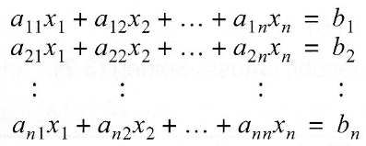
And this could be re-written in matrix form.
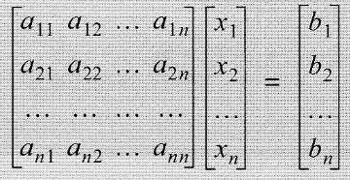

A system of linear equations can also be solved by using direct methods such as Gauss Elimination (using Upper Triangular and Lower Triangular Matrix), Gauss Jordan (using Diagonal Form), and LU Decomposition.
Upper Triangular –the system in this form has all zero coefficients below the diagonal and is solved by a procedure called Back Substitution. A similar form is used in the Gauss Elimination Method
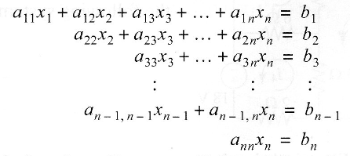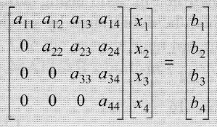

Lower Triangular – the system in this form has all zero coefficients above the diagonal and is solved by a procedure called Forward Substitution. A similar form is used in the Gauss Elimination Method.
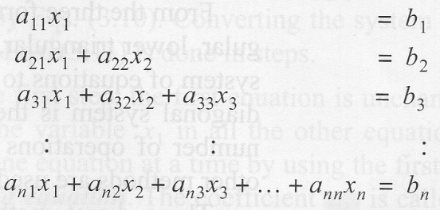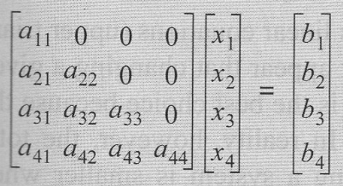

Diagonal Form– a system of this form has nonzero coefficients along the diagonal and zeros everywhere else. A similar form is used in the Gauss-Jordan Method
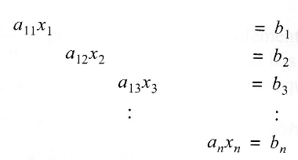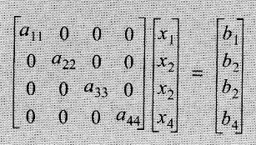

The LU decomposition method is a method for solving a system of linear equations [a][x]=[b].
In this method, the matrix of coefficients [a] is decomposed (factored) into a product of two matrices [L] and [U]
[a]=[L][U]
Where the matrix [L] is a lower triangular matrix and [U] is an upper triangular matrix.
With this decomposition, the system of equations to be solved has the form

[L][U][x]=[b] -----Eq.1

To solve this equation, the product [U][x] is defined as:
[U][x]=[y] -----Eq.2

and is substituted to Eq.1 to give
[L][y]=[b] ------Eq.3

The solution [x] is obtained two steps.
- Eq.3 is solved for [y]
- Then, the solution [y] is substituted in Eq.2, and that equation is solved for [x].

LU decomposition can be solved using Gauss Elimination methods, Crout’s Method & Choleski’s Method

- SOFTWARE NEEDED
ITEM NO. | DESCRIPTION | QUANTITY
 | MATLAB 2018 or higher version | 1

- METHODOLOGY
- Solve the following system of equations using the Gauss Elimination method using Excel. Then validate your answer using MATLAB.

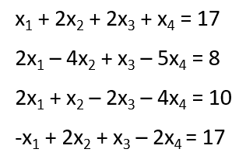
.

- Solve the following system of equations with the Gauss-Jordan elimination method using excel. Then validate your answer using MATLAB.
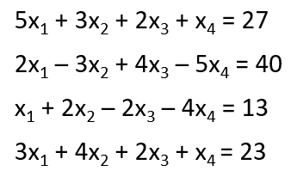
- Solve for i₁, i₂, i₃, & i₄ using LU DECOMPOSITION (Gauss Elimination). Validate that [A]=[L][U] using MATLAB.
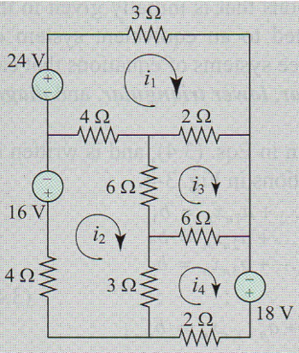

- OUTPUT
- Answer using excel file. Provide screenshots of your answer/s.
A.1
A.2
A.3
- Validation or your answer/s using MATLAB. Provide screenshots of your answer/s in Command Window. Send your m files via Canvas submission.
B.1
B.2
B.3
C. Screenshot of your group while performing the activity.

- QUESTIONS

- Using the created programs, differentiate the methods used under the direct Method of solving Linear Equations? Manual and program.
- Which is more efficient? Why?
- Share your thoughts and learning/s from this activity.
Marife
Jo-ann
Geoffrey

- CONCLUSION

